

Analysis and Design of Circuits Lab Part 1: Autumn Term weeks 4–6

6Department of Electrical and Electronic Engineering Imperial College London2019-v2



wUYANG ZHOU

# Lab preparation:

The node voltages are calculated by LTspice.

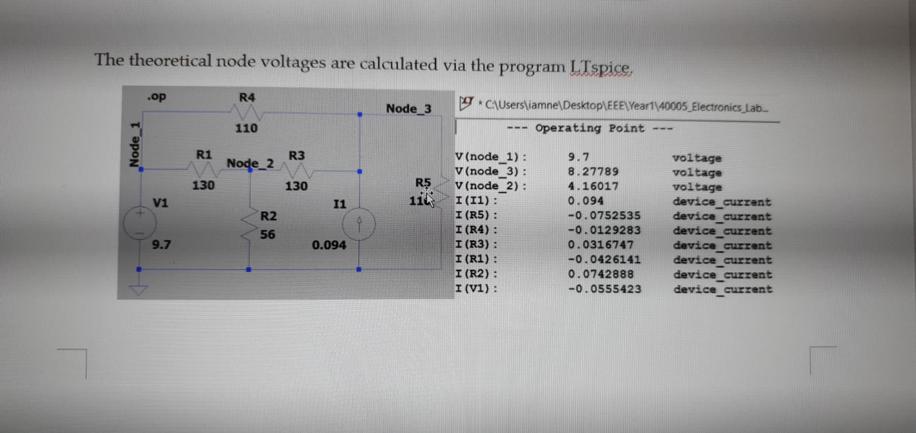

# Task 1. Find the resistors you need and build the circuit neatly on the breadboard

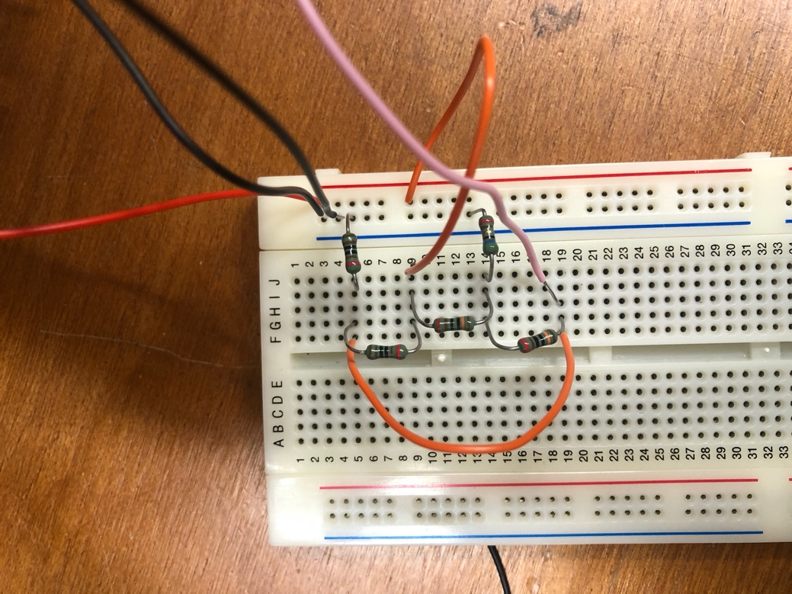

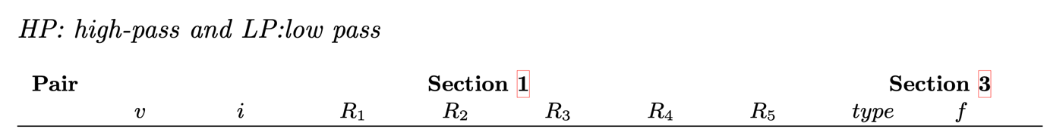



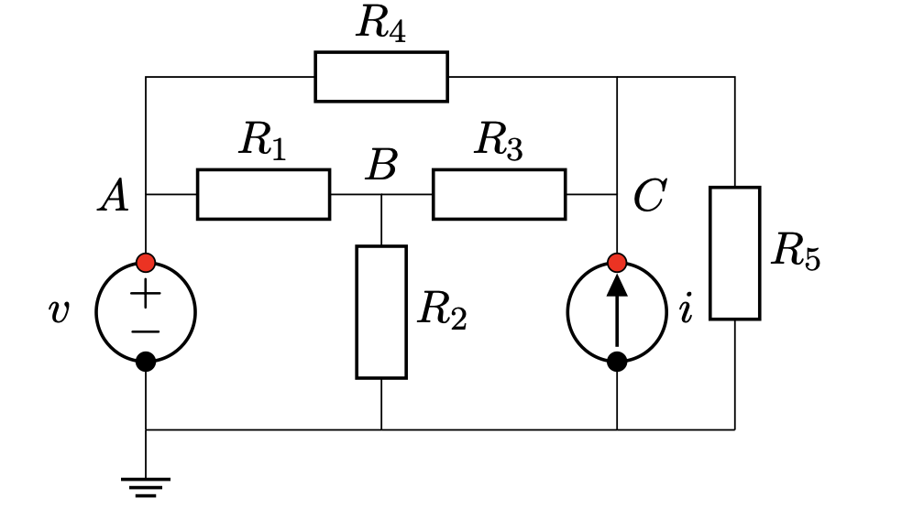

# Task 2. Set up the bench PSU to act as the voltage and current sources in your circuit.

(This step is necessary because the current limit adjustment of the bench power supply is not very precise, nor is the current display very accurate at the range you require.)

IF THE CURRENT LIMIT IS HIT FIRST, THEN IT IS A CURRENT SOURSE. (There will be red light on the signal generator)

IF THE VOLTAGE LIMIT IS HIT FIRST, THEN IT IS A VOLTAGE SOURCE.

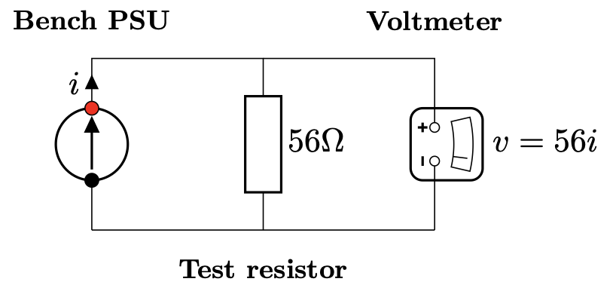

Connect the circuit as in the figure. And set the voltage power supply to 12V and the current limit to approximately the required value, which is 0.094A. The voltage drops to 56i, which is 5.27V. 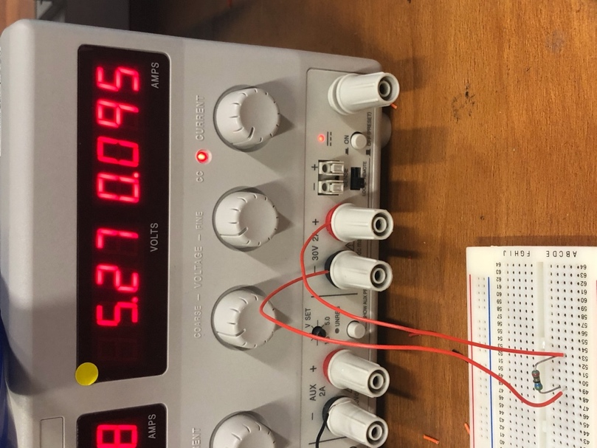

(since the current power supply is used in current limit mode, the voltage setting is the maximum and the voltage will not reach this level as the circuit is connected correctly.)

Connect the test load across the terminals and turn on the power supply.

The power supply only behaves like an ideal source within a limited range. As a voltage source the maximum current is limited by the current limit and as a current source the maximum voltage is limited by the voltage setting.

# Task 3. Measure and check the node voltages.

(Didn’t get the correct value in the beginning because the circuit was not correctly constructed.)

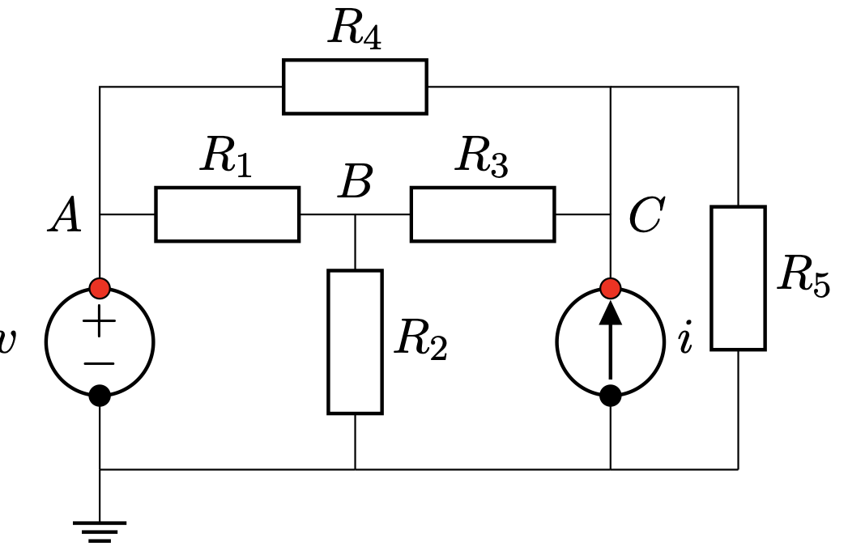

Node A: 9.694V

Node B: 4.15V

Node C: 8.26V

The measurements are almost the same as the ones we got in Lab preparation. Therefore, our circuit should be right.

# Task 4. Check the power dissipation of the resistors in your circuit.

P = v2/R

R1:0.236 W

R2:0.308 W

R3:0.130 W

R4:0.0187 W

R5:0.620W

We touched them. R5 is a hotter than all the others. R2 was warm.

# Task 5. Set up the oscilloscope to compare v1 and v2. Confirm that v1 = v2 when Z = R.

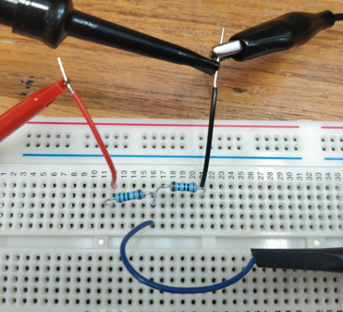Connect a circuit like this 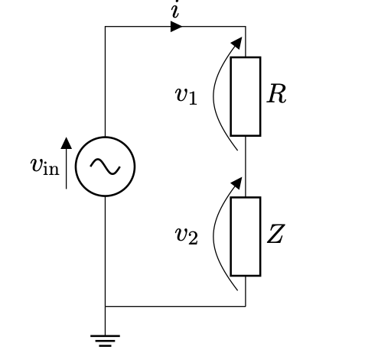

Make probe 2. x10, and probe 1. x1 because probe 1. is directly connected with a probe that is unable to set to be at x10.

The two channels on the oscilloscope measure voltage referenced to ground, which is defined as the point indicated thanks to earth wiring inside the signal generator. So it’s impossible to connect a scope probe to measure v1 directly, it would just create a short circuit to ground across Z.

V1 can be calculated as Vin-V2 by the maths function.

The following parts of the lab experiment will use AC signals from the function gener- ator instead of DC signals from the power supply. Generate vin from the signal generator with f = 1kHz and Vpp =3.5V and set up the oscilloscope with a trigger on CH1 and both signals shown at the maximum vertical size that will fit on the screen.

Press <Maths>, make it CH1, SUB, CH2. Double tap CH1 to eliminate CH1. It’s shown that V1=V2 when Z=R

# 

# Task 6. Check the accuracy of the auto measure functions of the oscilloscope.

Press MEASURE to turn on measurements. Choose the source (e.g. CH1, CH2, MATH) and the measurement type. Add the measurements ‘Amplitude’, ‘Peak–peak’ and ‘RMS’ for channels MATH (v1) and CH2 (v2). Compare the measurements and find which one match peak-to-peak measurements made by the cursors.

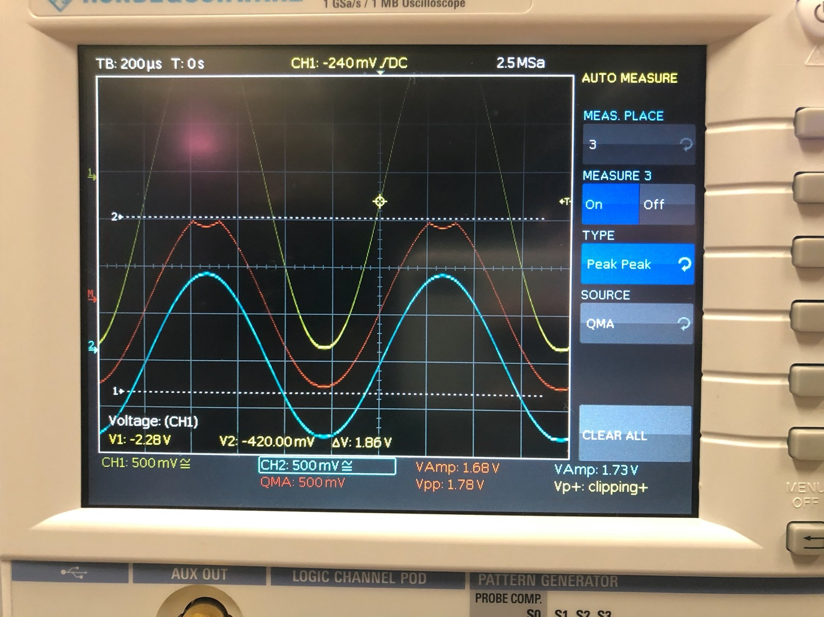

It’s not accurate. As the voltage difference should be 1.73V, but it shows 1.68V in amplitude mode and 1.78V in peak to peak mode.

(Amplitude mode is a biy more accurate.)

(Peak to peak mode includes noise.)

(RMS is the root mean value, real average voltage.)

# Challenge: source impedance of the signal generator

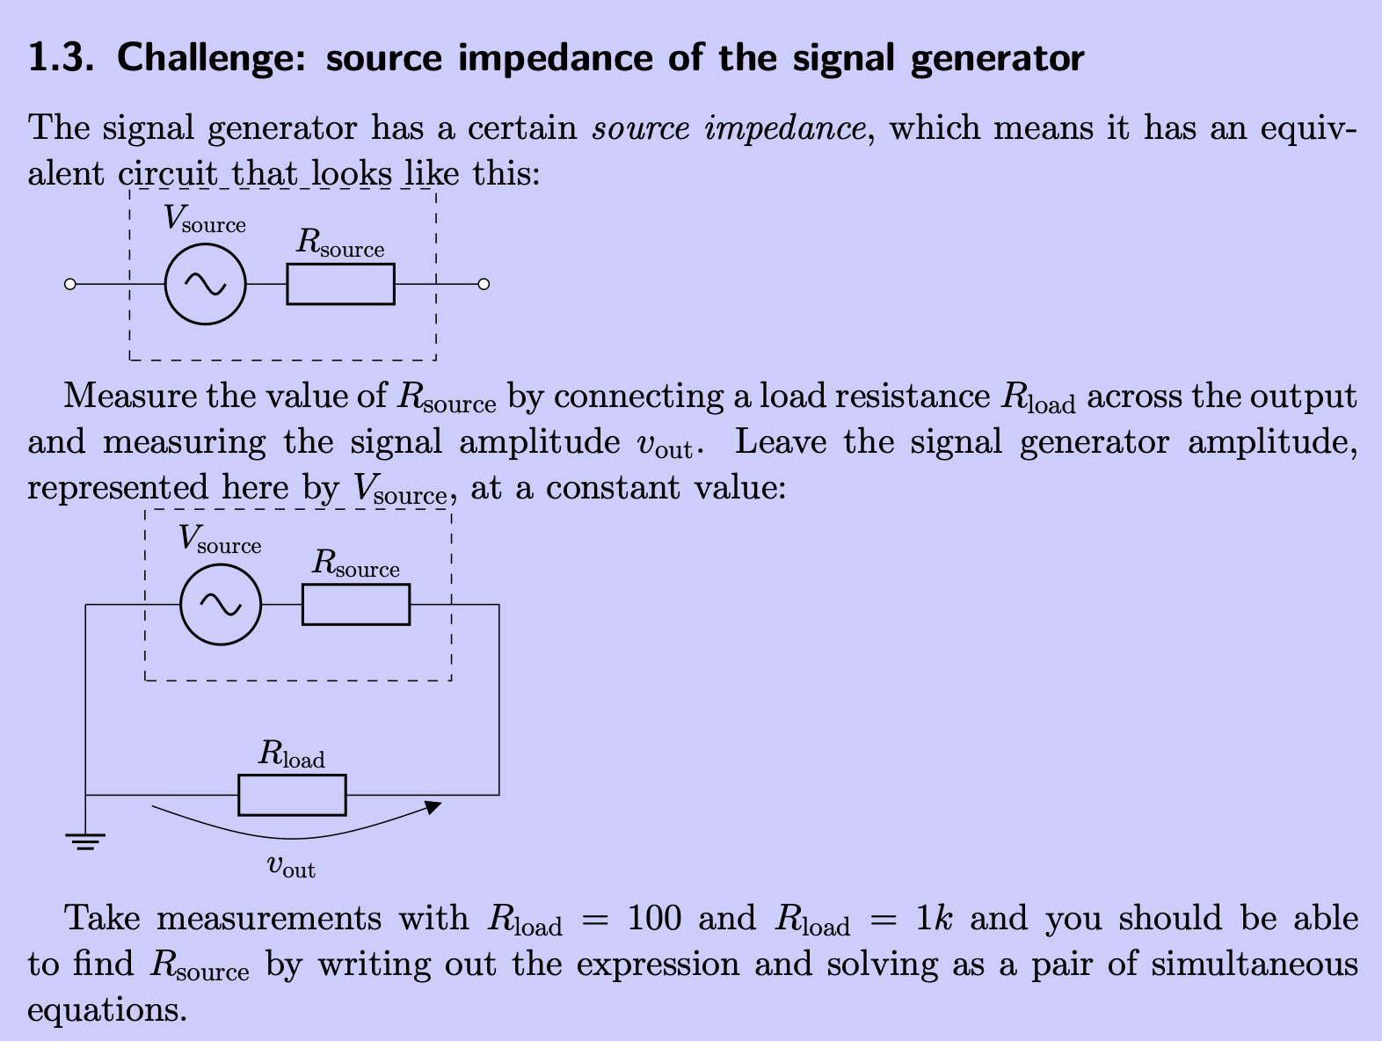

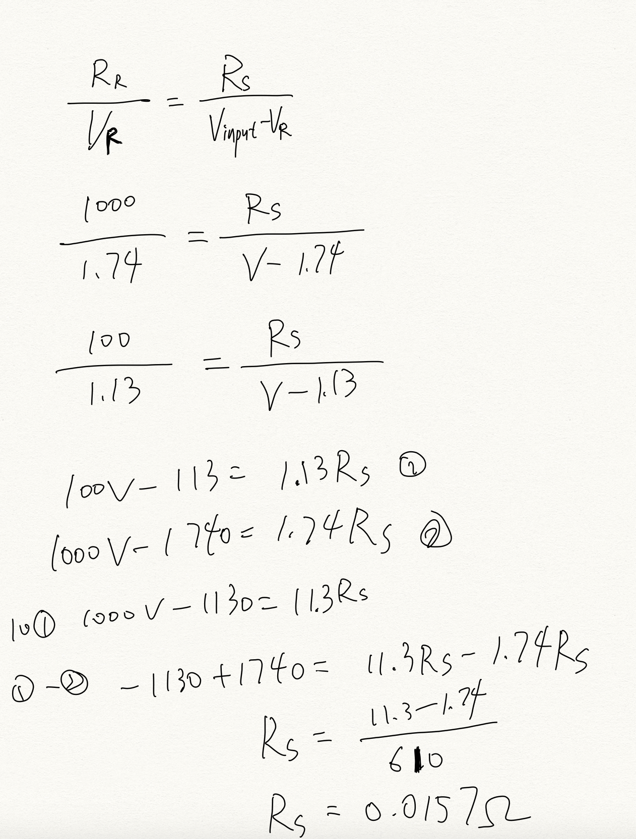

# Lab preparation for section 2

Real life inductors and capacitors have parasitic impedances, so that they can be drawn as below:

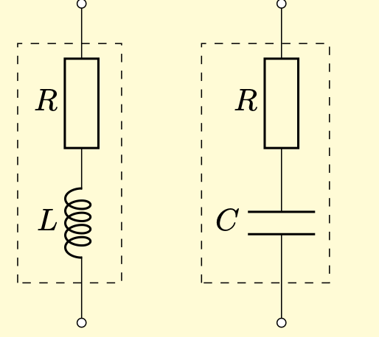

ZL = jωL+R

Mag: (ωL2 + R2 )1/2,

Arg: arctan(R/ ωL)

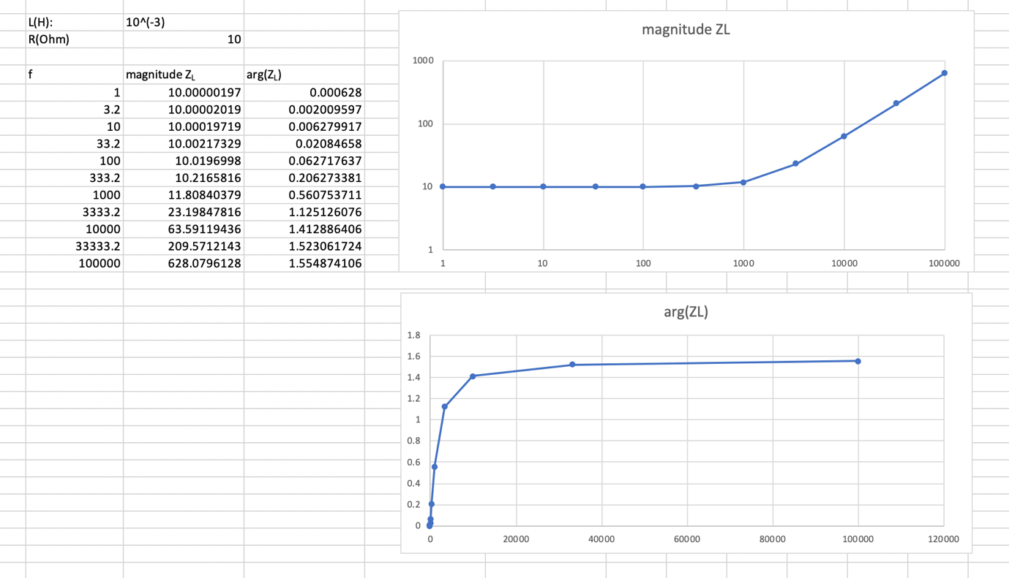

Set the graph to use logarithmic scales for axes showing f and |Z|, and linear scales for axes showing arg(Z).

Measuring voltages less than 50mV becomes increasingly inaccurate due to noise (fuzziness of the signal) and, once the vertical scale is decreased to its minimum, the signal appears small on the screen so it cannot be measured to the same precision. 🡪 the reason why we need to change resistors in Task 7 and Task 8.

# Task 7. Confirm that the 1μF and 1nF capacitors obey the equation |ZC| = 1/(ωC) between 1Hz and 100kHz.

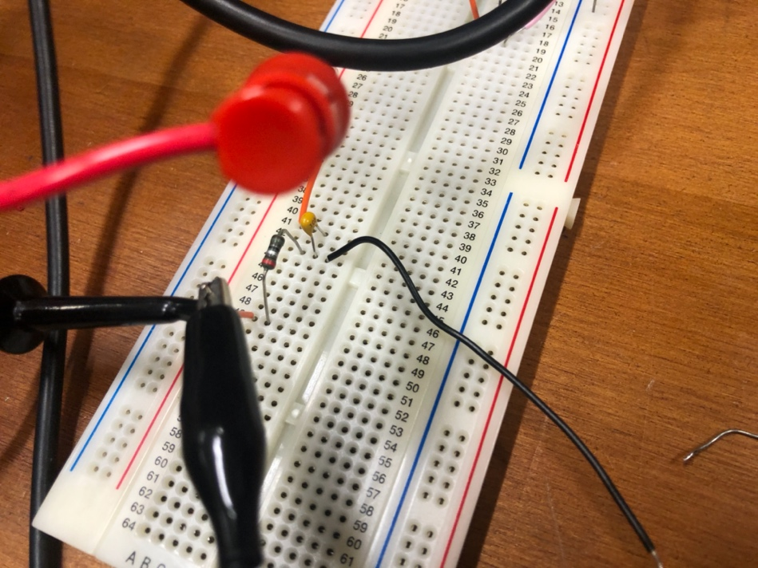

By connecting a capacitor and a resistor in series, the voltage across each of them is divided up according to their impedances. By varying the frequency, the impedance of the capacitor changes. Therefore, it is possible to find out the impedance of the capacitor at different frequencies.

(To be able to measure the voltage across the resistor and the capacitor, it is sometimes necessary to replace the resistor with a smaller resistance or a larger one as the oscilloscope is not able to measure voltages that are too small.)

In the end, by plotting the results we got on a diagram, we have confirmed the reciprocal relationship between impedance and frequency.

The first table has V2(MATH) as the voltage across the capacitor, and V1(CH2) as the voltage across the resistor. The second table has Vr as the voltage across the resistor, and Vc as the voltage across the capacitor.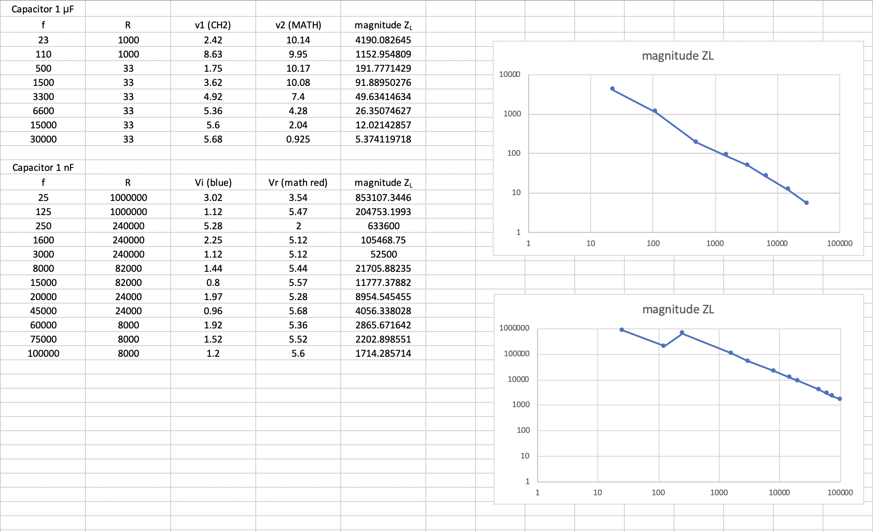



# Task 8. Characterise the impedance of the 1mH and 100mH inductors between 1Hz and 100kHz. Find the extent of frequencies over which they obey the ideal equation |ZL| = ωL.

The impedance of the inductor can be measured in the same way as the capacitors.

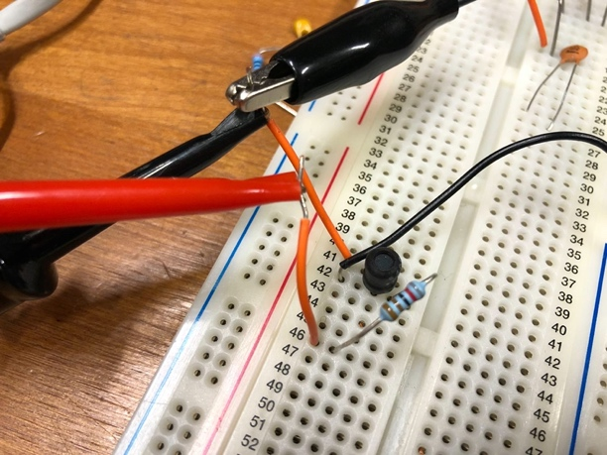

The only difference in the relationships of impedances of an inductor to frequencies and the relationship of the impedance of a capacitor to frequency is that the impedance of an inductor is directly proportional to frequency, whereas the impedance of a capacitor has a reciprocal relationship to frequency.

(Inductors tend to be less faithful to an ideal component than capacitors, particularly at low frequencies when the parasitic resistance (the fixed internal resistance) of the coil of wire can become significant compared to the reactance. Furthermore, capacitance between the tightly-packed turns of wire can cause non-ideal behaviour at high frequencies too. At very high frequencies, a single capacitor may have a very small parasitic inductance, which forms a resonant system. At very high frequencies, a single inductor may have a very small parasitic capacitance, which forms a resonant system.)

For the 1mH inductor, it obeys the ideal equation |ZL| = ωL in the frequency range of 750 ~ 45000.

For the 100mH inductor, it obeys the ideal equation |ZL| = ωL in the frequency range of 2000 ~ 50000.

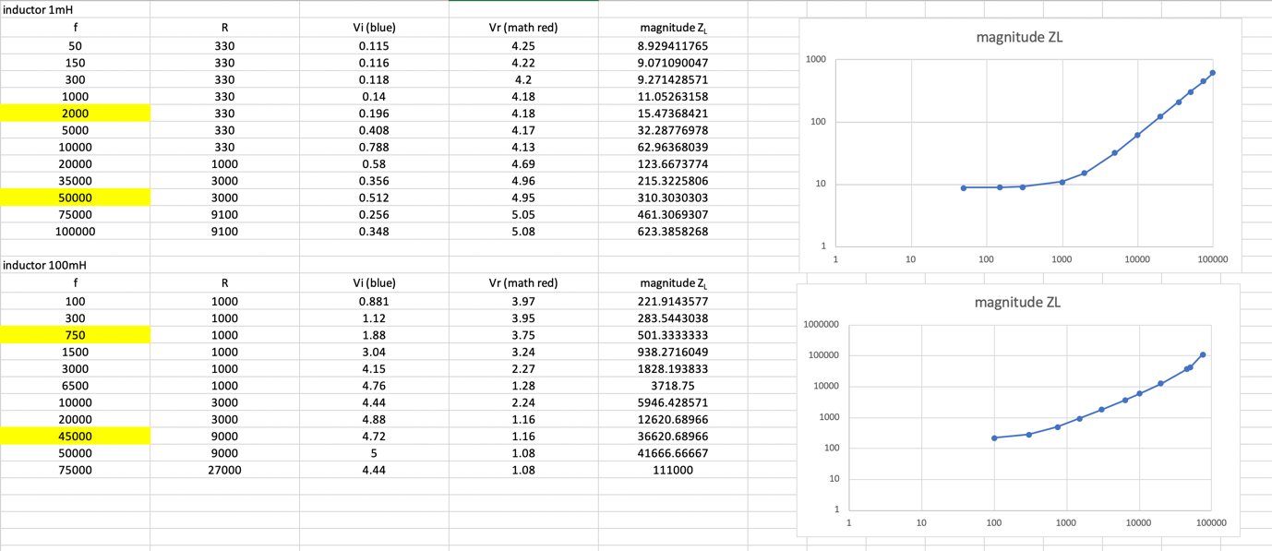

# Task 9. Fit your model to the experimental data and create a graph that compares them.

They fit very well.

# Challenge 2: Find the capacitances of unknown capacitors and the impedance of unknown inductors.

At very high frequencies, it is not possible to get the exact voltage values for the experiment involving inductors.

(error example: The output voltage shown is higher than the input voltage shown. This is because at high frequencies, the impedance of the inductor is too high and dominates all the input voltage)

Reason:

1. Margin of error.
2. Inductor can have a parasitic capacitance, which forms a resonant system at high frequencies.
3. Capacitors can have a parasitic inductance, which forms a resonant system at high frequencies.

We could not get the exact capacitances of the capacitors and the exact impedances of the inductors at very low or very high frequency. This is because at low frequencies, the parasitic impedances of the inductors and the capacitors are significant. And at high frequencies, a resonance may occur.

**Capacitors**

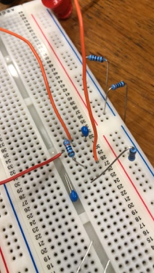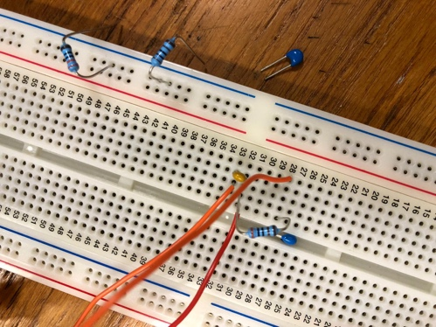

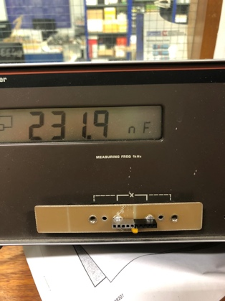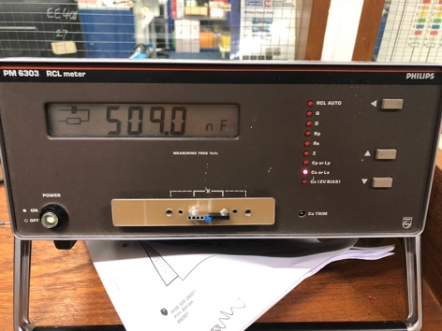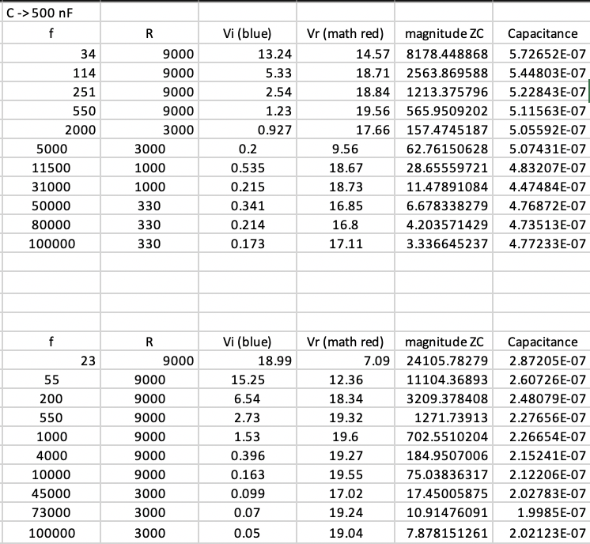



**Inductors**

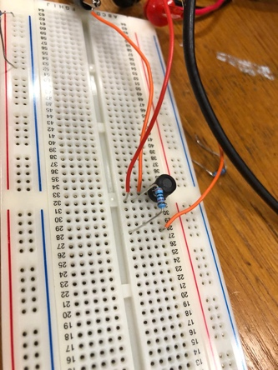 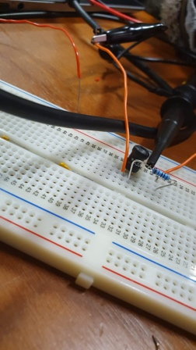

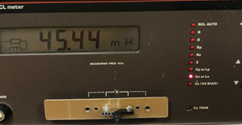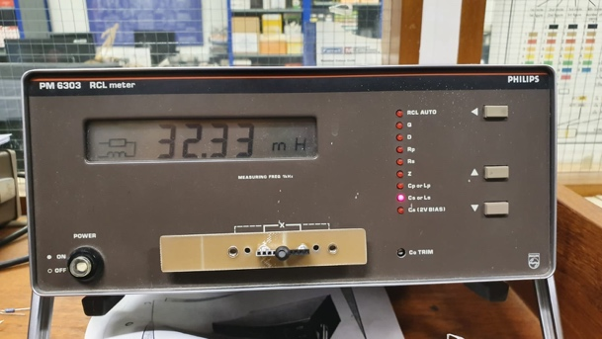

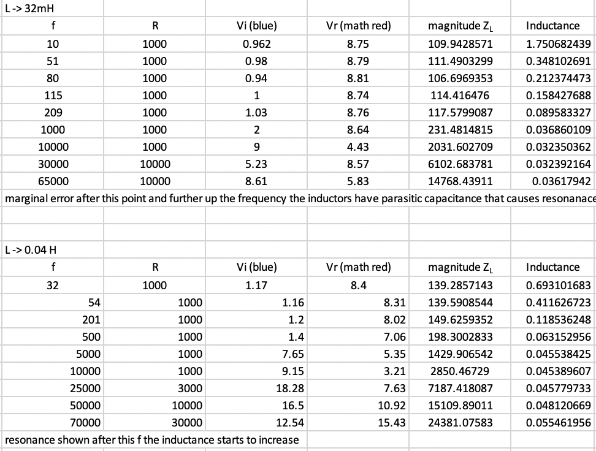

Resonance causes gain of the circuit to rise, which makes Vr smaller and Vi larger, resulting in wrong inductance values. Letting Vr be smaller and Vi be larger makes the ratio between Vr and Vi different to the ratio between the impedance of the resistor and the inductor. (Therefore, the inductance calculated starts to increase after a certain frequency.)

# Lab preparation for section 3 (Design a low-pass filter)

# 

 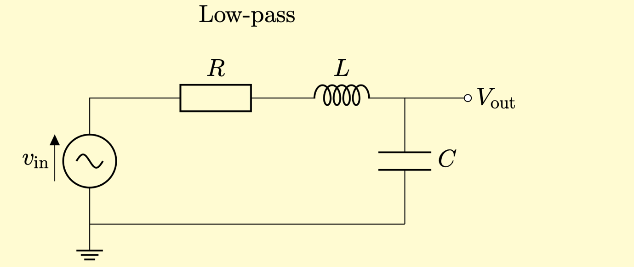

Requirements:

LP f= 1100

Wc = 1100* 2pi = 6911 rad/s

Zeta= 1 (critically damped) Critically damped: The system returns to equilibrium as quickly as possible without oscillating. Large zeta means more loss, smaller peak.

**The components we picked: (The reason is shown by the calculation on the next page)**

R=1300 ohm

L = 100mH

C = 220nF

The exact resonant frequency: 7225rad/s (within 10% of the specification) 1150Hz

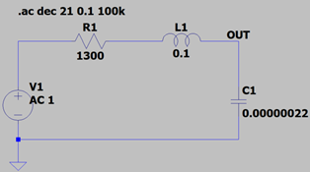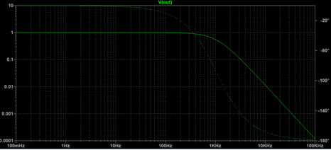The impedance at the resonant frequency was not 0 because the parasitic resistance of the coil of wire can become significant compared to the reactance when reactance is meant to be cancelled out.

The phase response graph behind is a bit blurry.

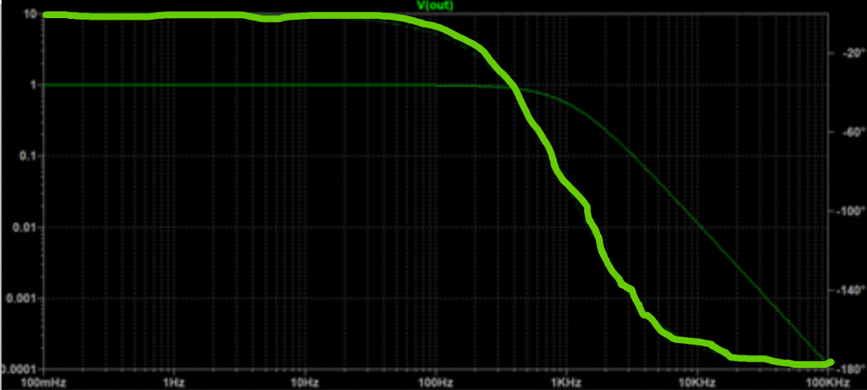

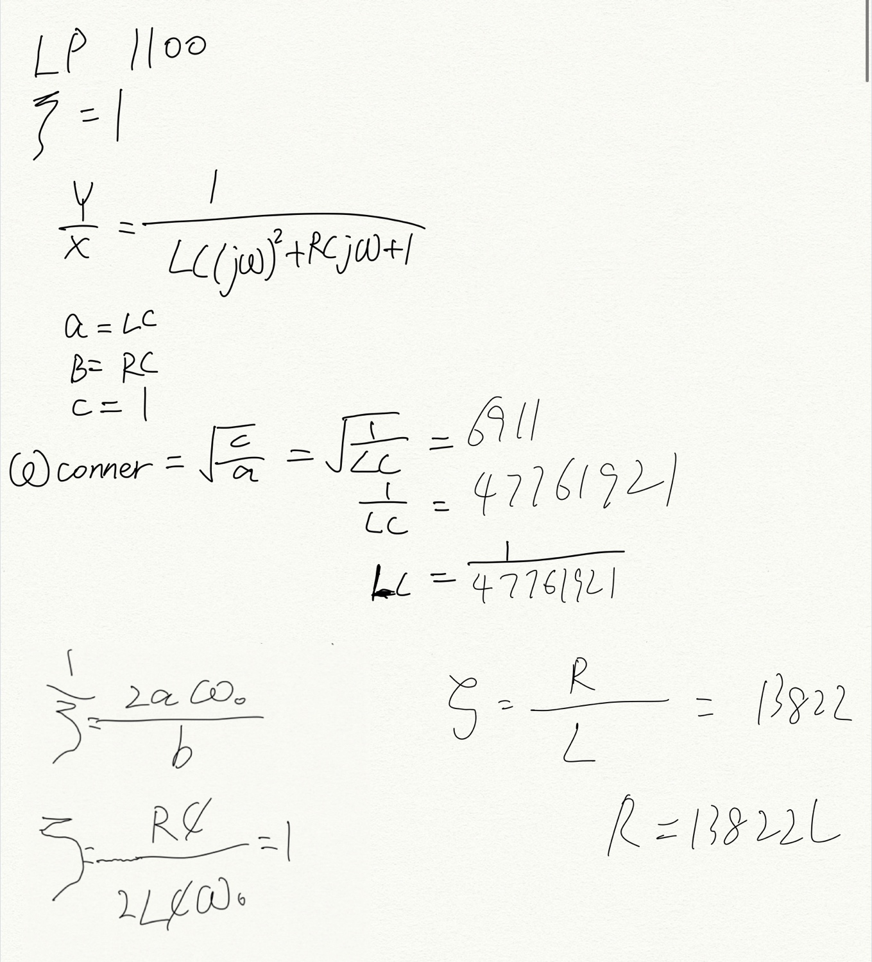

In [signal processing](https://en.m.wikipedia.org/wiki/Signal_processing), **phase response** is the relationship between the [phase](https://en.m.wikipedia.org/wiki/Phase_(waves)) of a [sinusoidal](https://en.m.wikipedia.org/wiki/Sine_wave) input and the output [signal](https://en.m.wikipedia.org/wiki/Signal_(information_theory)) passing through any device that accepts input and produces an output signal, such as an [amplifier](https://en.m.wikipedia.org/wiki/Amplifier) or a [filter](https://en.m.wikipedia.org/wiki/Filter_(signal_processing)).

# Task. 3.1.1. and 3.1.2.

## The purpose of task 3.1.1. is to find the minimum impedance of the Z, and see if there’s a difference between the theoretical impedance of Z at the resonant frequency and the exact impedance of Z at the resonant frequency.

It was shown by the data collected that the impedance of Z at resonant frequency (at its minimum) is not zero, but 19(excel table below). This is because that inductors and capacitors have parasitic impedances caused by the wires.

There is a minimum as the reactance of the inductor and the reactance of the capacitor cancel out at resonant frequency.

In series:

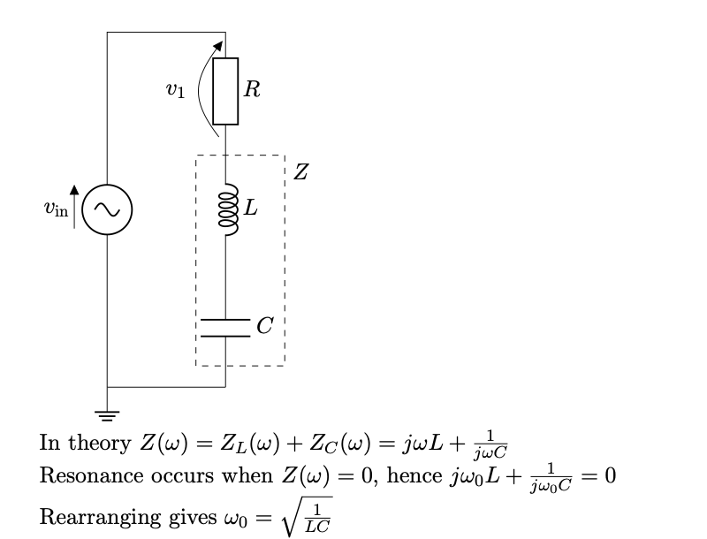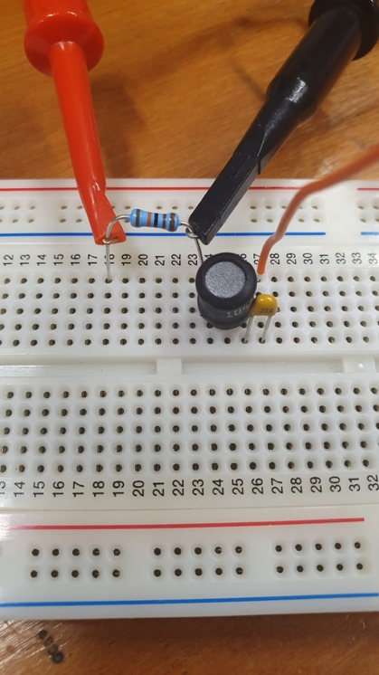

## The purpose of task 3.1.2. is to find the maximum impedance of the Z.

There is a maximum value because the impedance of Z at the resonant frequency can be written as However, in reality, it is measured to be 89 ohm only. (Excel table below) This is because Zc – ZL is not actually zero, it is determined by

Their parasitic impedances.

In parallel:

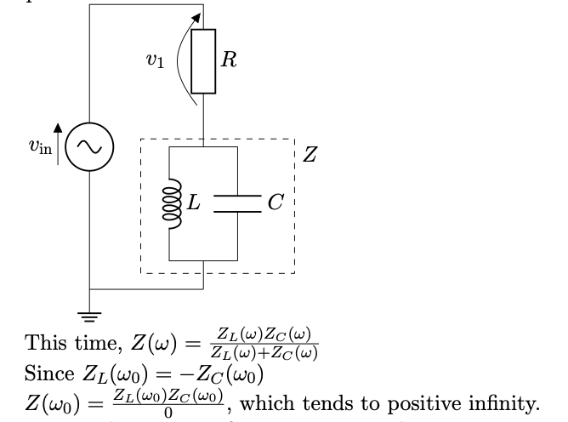

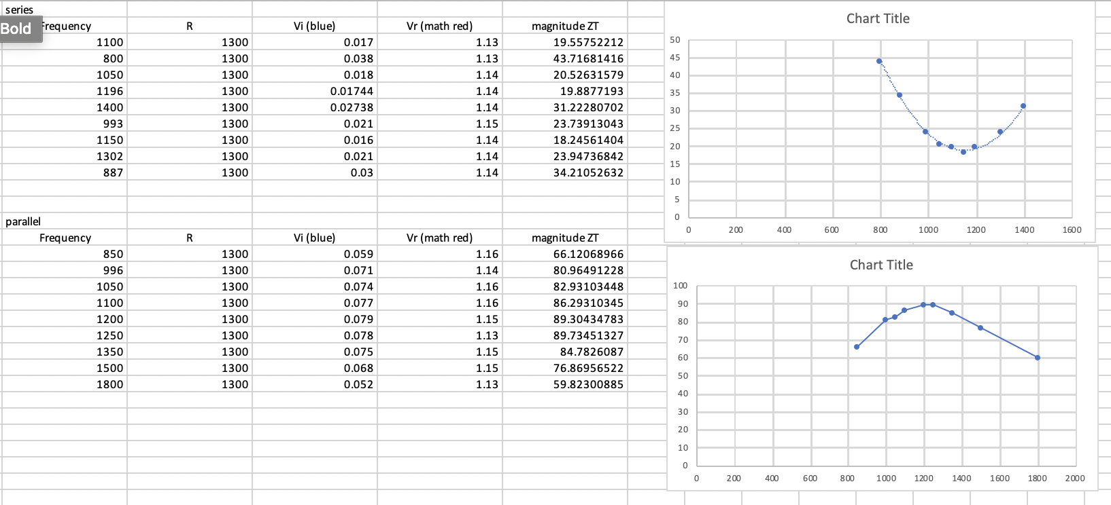



# Task. 3.2.1. First-order filter.

## Measure and plot the transfer functions of RC high-pass and low-pass filters made from a 1μF capacitor and 1kΩ resistor. Frequency and |T(f)| should be plotted on logarithmic axes and arg(T(f)) should be plotted on a linear axis.

## ***Low-pass filter (to make it a high pass filter, we just switched the positions of the resistor and the capacitor.)***

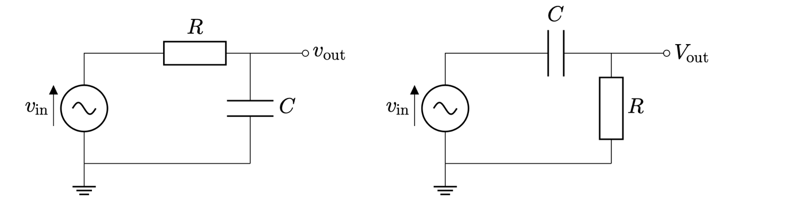The magnitude is the ratio of the voltage amplitudes and the phase is the difference in phase angle between the output and input sine waves.

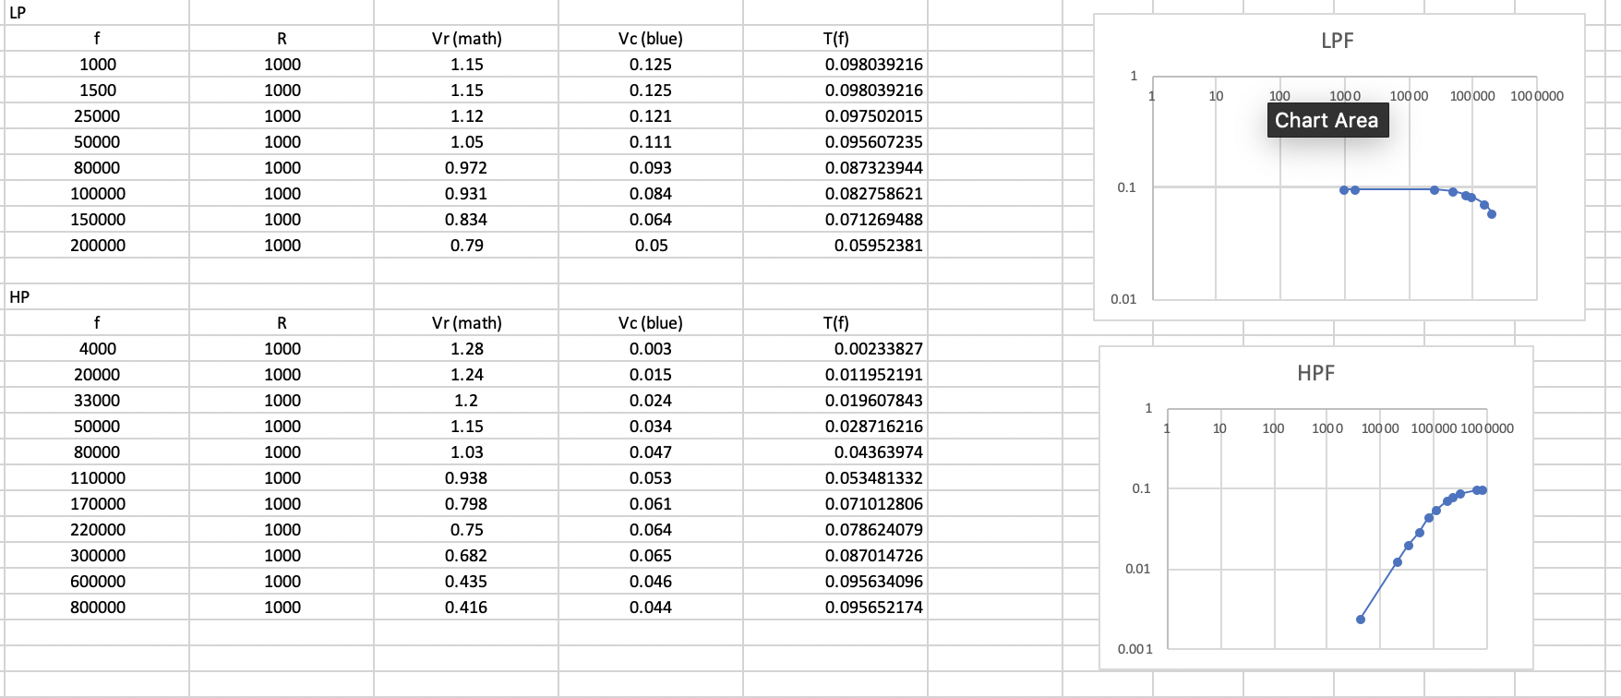*Note: the phase measure in AUTO MEASURE always varies, so the most often shown value is chosen. (To avoid the variation, we can press <ACQUIRE> -- <ARITHMETRIC>--<SMOOTH> on the oscilloscope to reduce the impact of the noise.)*

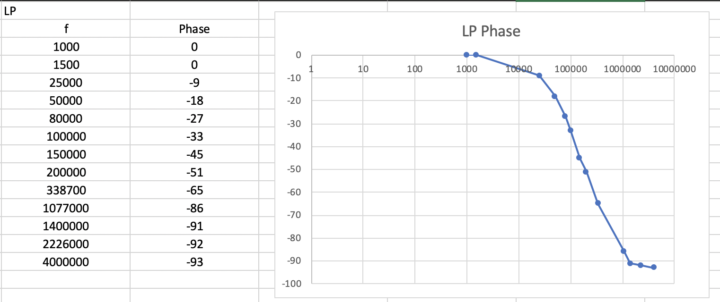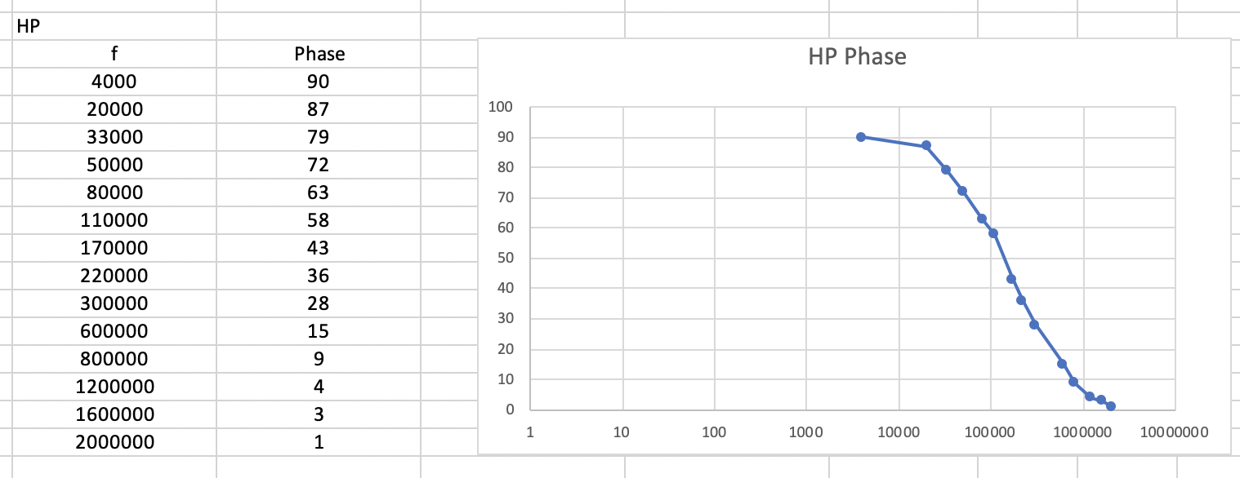

*We can see that the frequencies of the turning points in the phase response graphs correspond to the corner frequencies in the magnitude response graphs.*

# Challenge 3: test your second-order filter.

Build the filter you designed in the preparation activity. Measure the magnitude and phase responses between 1Hz and 100kHz. Produce a plot comparing the magnitude and phase responses with the results of your simulation. Explain any discrepancies.

Note: It was initially not possible to get the magnitude of the gain after 20kHz because the capacitor’s impedance is too low. Therefore, we made the <-20dB> button not pressed in on the function generator to make the input voltage bigger, which gives a larger value and reduces the impact of the noise.

However, we still could not get any more values after 65kHz because the impedance of the capacitor is too low at high frequencies. After that, the power supply we had could not supply a voltage across the capacitor that is high enough for the oscilloscope to measure accurately.

Phase was measure directly using the oscilloscope. The gain was calculated as

Vacross C/ Vinput

Furthermore, to reduce the impact of the noise, we can also press <ACQUIRE>--<ARITHMETRIC>--<Smooth> on the oscilloscope.

We did not see any significant discrepancy.

